**Topics: Confidence Intervals**

1. For each of the following statements, indicate whether it is True/False. If false, explain why.
2. The sample size of the survey should at least be a fixed percentage of the population size in order to produce representative results.
3. The sampling frame is a list of every item that appears in a survey sample, including those that did not respond to questions.
4. Larger surveys convey a more accurate impression of the population than smaller surveys.

Ans:

I. False

The statement is false because the sample size of a survey should not necessarily be a fixed percentage of the population size to produce representative results. The appropriate sample size depends on various factors, including the desired level of confidence, margin of error, and the variability within the population being studied. It's important to calculate the sample size based on statistical principles to ensure that it accurately represents the population.

II. True. The sampling frame is a list of every item that appears in a survey sample, including those that did not respond to questions. It represents the entire set of elements from which a sample is drawn.

III. True. Larger surveys generally convey a more accurate impression of the population than smaller surveys. Larger sample sizes reduce the margin of error and increase the precision of estimates, which means that the survey results are more likely to closely reflect the true characteristics of the population.

1. *PC Magazine* asked all of its readers to participate in a survey of their satisfaction with different brands of electronics. In the 2004 survey, which was included in an issue of the magazine that year, more than 9000 readers rated the products on a scale from 1 to 10. The magazine reported that the average rating assigned by 225 readers to a Kodak compact digital camera was 7.5. For this product, identify the following:
2. The population
3. The parameter of interest
4. The sampling frame
5. The sample size
6. The sampling design
7. Any potential sources of bias or other problems with the survey or sample

Ans:

The Population: The population in this survey would be all readers of PC Magazine who are interested in or have experience with different brands of electronics. This would include all the magazine's readers who could potentially provide ratings for electronics products.

The Parameter of Interest: The parameter of interest would be the average rating assigned by all readers of PC Magazine to the Kodak compact digital camera. In this case, it's the population mean rating for this specific product.

The Sampling Frame: The sampling frame would be all PC Magazine readers who had the opportunity to participate in the survey. This includes all readers who received the survey request, regardless of whether they chose to respond or not.

The Sample Size: The sample size for the Kodak compact digital camera rating is 225 readers.

The Sampling Design: The description doesn't provide specific details about the sampling design, but it seems to be a convenience or voluntary sampling design. PC Magazine asked all of its readers to participate, and those who chose to respond were included in the sample.

Potential Sources of Bias or Other Problems are:

1. If not all readers responded to the survey request, the sample might not fully represent the entire population of readers, potentially introducing bias.
2. It's not clear from the description whether the survey used random sampling.
3. For each of the following statements, indicate whether it is True/False. If false, explain why.
4. If the 95% confidence interval for the average purchase of customers at a department store is $50 to $110, then $100 is a plausible value for the population mean at this level of confidence.
5. If the 95% confidence interval for the number of moviegoers who purchase concessions is 30% to 45%, this means that fewer than half of all moviegoers purchase concessions.
6. The 95% Confidence-Interval for *μ* only applies if the sample data are nearly normally distributed.

Ans:

1. True.

The confidence interval suggests that we are 95% confident that the true population mean falls within the range of $50 to $110. Since $100 falls within this range, it is a plausible value for the population mean.

1. False. If the 95% confidence interval for the number of moviegoers who purchase concessions is 30% to 45%, it does not necessarily mean that fewer than half of all moviegoers purchase concessions. The confidence interval represents a range of plausible values for the population proportion, but it doesn't provide information about whether it's less than half or not.
2. False. The 95% confidence interval for μ (the population mean) does not require the sample data to be nearly normally distributed. The confidence interval for the population mean can be used even if the sample data are not normally distributed, as long as the sample size is sufficiently large. ( according to central limit theorem).
3. What are the chances that?
4. ¼
5. ½
6. ¾
7. 1

Ans: B) ½

There is 50% chance that the sample mean is greater than population mean.

1. In January 2005, a company that monitors Internet traffic (WebSideStory) reported that its sampling revealed that the Mozilla Firefox browser launched in 2004 had grabbed a 4.6% share of the market.

1. If the sample were based on 2,000 users, could Microsoft conclude that Mozilla has a less than 5% share of the market?
2. WebSideStory claims that its sample includes all the daily Internet users. If that’s the case, then can Microsoft conclude that Mozilla has a less than 5% share of the market?

Ans:

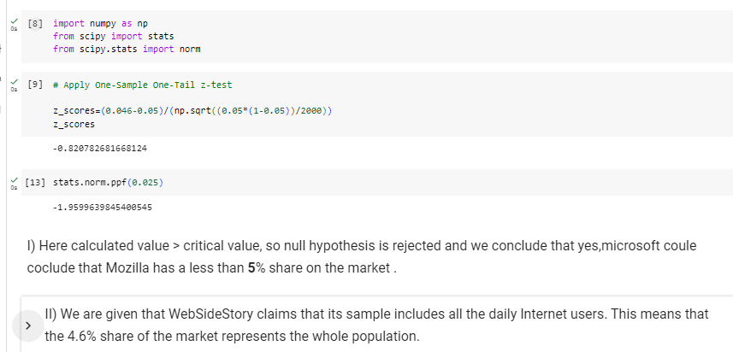

1. A book publisher monitors the size of shipments of its textbooks to university bookstores. For a sample of texts used at various schools, the 95% confidence interval for the size of the shipment was 250 ± 45 books. Which, if any, of the following interpretations of this interval are correct?
2. All shipments are between 205 and 295 books.
3. 95% of shipments are between 205 and 295 books.
4. The procedure that produced this interval generates ranges that hold the population mean for 95% of samples.
5. If we get another sample, then we can be 95% sure that the mean of this second sample is between 205 and 295.
6. We can be 95% confident that the range 160 to 340 holds the population mean.

Ans: Option C is correct.

The correct interpretation of a 95% confidence interval is that if you were to take many random samples from the population and calculate a confidence interval for each sample, approximately 95% of those intervals would contain the true population mean. So, this interpretation is correct.

1. Which is shorter: a 95% *z*-interval or a 95% *t*-interval for *μ* if we know that σ =s?
2. The z-interval is shorter
3. The t-interval is shorter
4. Both are equal
5. We cannot say

Ans: A 95% z-interval for μ is shorter than a 95% t-interval for μ when σ = s.

The reason for this is that the z-interval uses the standard normal distribution (z-distribution) for calculating the margin of error, while the t-interval uses the t-distribution. The t-distribution has heavier tails compared to the standard normal distribution, which means it has more variability and requires wider intervals to achieve the same level of confidence.

Questions 8 and 9 are based on the following: To prepare a report on the economy, analysts need to estimate the percentage of businesses that plan to hire additional employees in the next 60 days.

1. How many randomly selected employers (minimum number) must we contact in order to guarantee a margin of error of no more than 4% (at 95% confidence)?
2. 600
3. 400
4. 550
5. 1000

Ans:

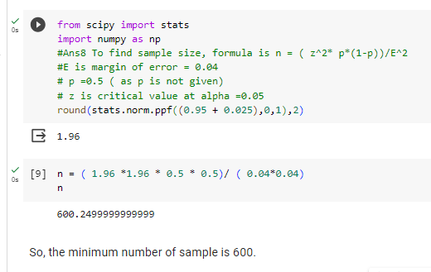

1. Suppose we want the above margin of error to be based on a 98% confidence level. What sample size (minimum) must we now use?
2. 1000
3. 757
4. 848
5. 543

Ans:

